# Database log

## May 18th

Created the h2go database using phpMyAdmin

Made the members table to store their data

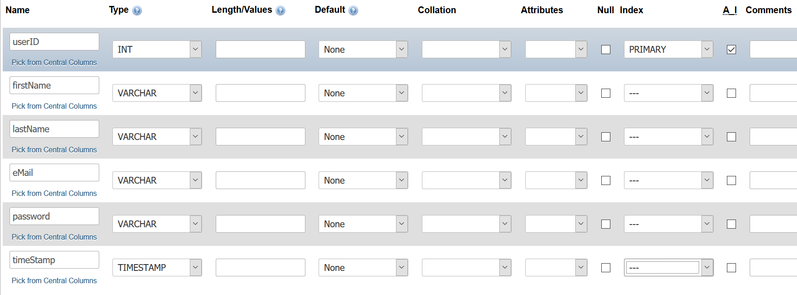

## May 23rd

Added a connection script so that the website can connect to the database

Made the sign-up page insert data into the database. For some reason the email wasn’t inserting but I realised that I had made a typo in the code and it was trying to insert it into a non-existent row. RIP

Made a quick login page that takes the existing emails in the database and compares them with the entered email and password. If everything matches, the user logs in

Made the update page replace data in the database. Works well woop!

I also made it so that if the user is logged in, they see one nav bar and if they aren’t logged in, they see a different one! This might not belong here, but it excites me so I’m leaving it :D

## May 25th

Also made a quick log out function. It was a bit of a drag because Jackie and I both tried several methods of logging out such as unsetting the userid but that didn’t work so we started and destroyed the session to get it to work. I’m proud to say that I found that solution

## May 30th

Made the product, cart and sale tables and added userAddress to the user table. Also renamed members to user. The product table includes information about the products such as their type (jar, bottle, packet, etc.), size, price and other details. The cart table had the productid, name, price, quantity and total price. The id, name and price all came from the product table whereas the quantity and total price originated here. The sale table acts as a receipt and has a saleid and stores the productid, userid, quantity, total price, timestamp, address and price.

## June 8th

(Over the course of June 6th and 8th) I decided to delete the sales table because PayPal does the whole receipt thing and I don’t need it because I can’t implement it properly anyway. Also, it’s not like I’ll have actual customers… I also deleted the (total)price and quantity because it can drag that from the productid which is cool. And the total price will be calculated just using PHP. I added a userid so that the user can keep teir cart even if they log out or leave the website.

I inserted mock data into the user table so that I could have users in my database that weren’t just “Dan” or “Cool guy”. I used 50 different specimens. I also encountered a problem with the timestamp. The users had no timestamp when they were inserted so I made one up for them. It doesn’t really matter since they’re FAKERS. Also added the products into the product table because the website needs products to purchase huzzah.

## June 29th

I removed the productdetails from the product table because I wasn’t going to end up using it and we need to spare each and every bit of storage in our database 😊.

## July 4th (isn’t this part of Katy Perry’s “Firework”?)

I removed the cart table because apparently, we’ll just be using PHP for the cart instead of a table to store it. Floats my boat. I also added an images row in the products table because my website has a for loop and for the product’s images to be available I need to put it into the loop but that doesn’t work without the images row. I only store the name of the image in it, though, not the whole image, since space costs $$$ and we don’t have $$$. Also, images weigh a lot. It’s hard to explain how the thing works but you can see it in my code, it’s pretty self-explanatory I’d say.